Coronavirus disease 2019 (COVID-19)
Situation Report – 89
Data as receiv ed by WHO from national authorities by 10:00 CEST, 18 April 2020

HIGHLIGHTS
- No new country/territory/area reported cases of COVID-19 in the past 24 hours.

- WHO Regional Director for Europe Dr Hans Henri P. Kluge, has released a statement on the transition to a ‘new normal’ during the COVID -19 pandemic, stressing that it must be guided by public health principles. His statement is available here and it complements new guidance on adjusting public health and social measures, available here.

- Refugees and migrants face the same health risks from COVID-19 as their host populations. WHO has published new guidance, available here, for refugees and migrants to be included in the public health response to the COVID-19 pandemic.

- WHO and Global Citizen are joining forces with many of the world’s leading musicians, comedians and humanitarians for the “One World, Together At Home” global special. It will be broadcast/livestream on major social media networks, streaming services, and major television networks worldwide on 18– 19 April 2020. Further information and local listings are available on the Global Citizen website here.

- In the ‘Subject in Focus’ below, WHO presents data on COVID-19 cases by age and sex. This data is based on nearly 750 000 WHO case reporting forms received from 113 countries, territories and areas.
SITUATION IN NUMBERS
total (new cases in last 24 hours)

Globally
2 160 207 confirmed (85 678)
146 088 deaths (6710)

European Region
1 086 889 confirmed (36 018)
97 201 deaths (3721)

Region of the Americas
784 272 confirmed (40 665)
35 742 deaths (2714)

Western Pacific Region
129 256 confirmed (1661)
5598 deaths (40)

Eastern Mediterranean Region
120 683 confirmed (4859)
5784 deaths (122)

South-East Asia Region
25 291 confirmed (1731)
1134 deaths (83)
African Region
13 104 confirmed (744)
616 deaths (30)

WHO RISK ASSESSMENT
Global Level Very High

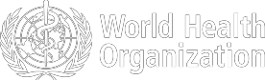

Figure 1. Countries, territories or areas with reported confirmed cases of COVID-19, 18 April 2020
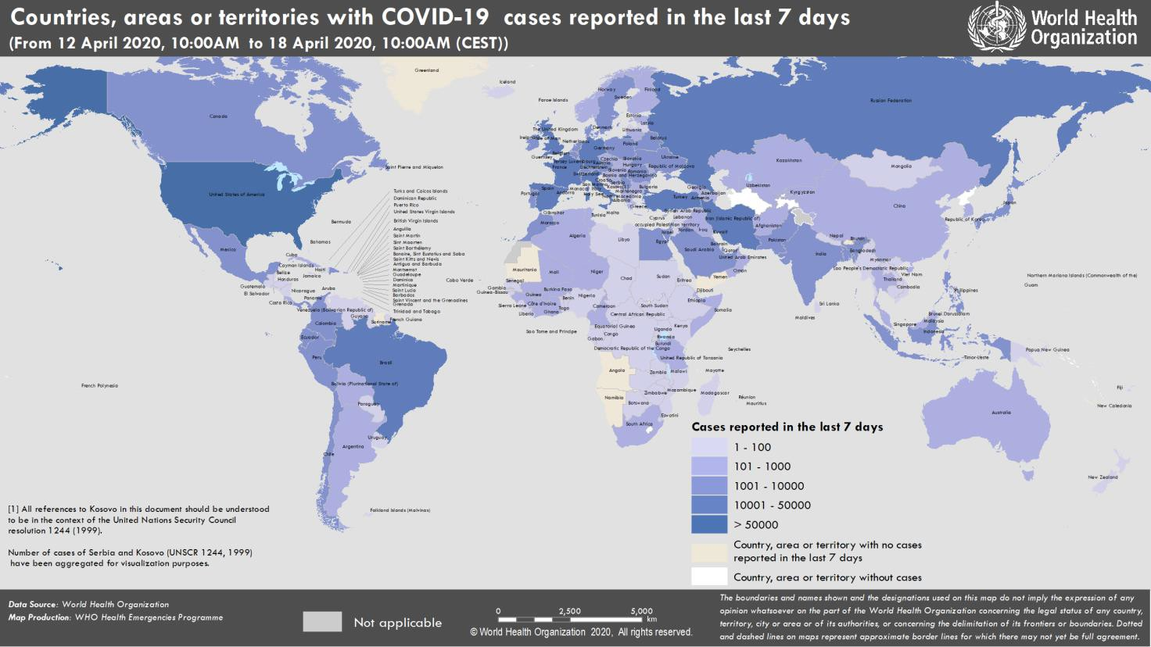

SUBJECT IN FOCUS: WHO global case-based surveillance for human infection with coronavirus disease (COVID-19)

Following the notification of COVID-19 cases among travelers from Wuhan, China in early January, WHO set up a global surveillance system to gather essential information to monitor the epidemic. Beginning on 26 January, all Members States were requested to immediately report confirmed and probable cases of COVID -19 to WHO with a minimal set of information through a standardized case reporting form (CRF).

As of 13 April, a total of 747 546 confirmed cases were documented via case reporting forms (CRFs) received from 113 countries, territories and areas across five different WHO regions and three international conveyances. The number of cases with a CRF accounts for 44.0% of the confirmed cases reported globally as of 13 April 10 AM. Distribution per region shows that 316 076 (42.3%) of CRFs were reported from the European Region, 415 484 (55.6%) from the Region of the Americas, 10 662 (1.4%) from the Western Pacific Region, 4717 (0.6%) from the Eastern Mediterranean Region, 136 (0.02%) from the South-East Asia Region, and none from the Africa Region. An additional 471 CRFs have been submitted from international conveyances. It is important to note that of the cases which are documented with CRFs so far, the United States of America, Italy and Germany account for 74% of all cases in the database. Thus, these data should not be considered representative of all globally confirmed COVID -19 cases.

Distribution by age and sex of confirmed COVID-19 cases reported to the WHO case-based surveillance system globally to date

A total of 716 570 CRFs (95.9%) reported information on age and sex. The sex ratio (male to female) among the confirmed cases is 1.03:1, and the median age is 51 (interquartile range, IQR: 36-65) years. For males, the median age is 52 (IQR 37-65) years, and for females 50 (IQR 35-64) years. The sex ratio varies significantly with age in all ranges except 10-19 years. The largest sex ratios (male to female) are observed amongst the 0-9 year (1.16), 60-69 year (1.27:1), and 70-79 year (1.34:1) age groups. Conversely, the lowest sex ratios (i.e. those showing more females than males) are found in the 20-29 year (0.85:1) and 80 years and over (0.78:1) age groups (Figure 2). When cases reported from the United States, Germany and Italy are excluded, the overall sex ratio changes to 0.95:1 (more females than males amongst the cases), while there remains an excess of males in the 0-9, 60-69 and 70-79 year age groups (data not shown).

Figure 2: Distribution by age and sex of confirmed COVID-19 cases reported to the WHO case-based surveillance system to date.

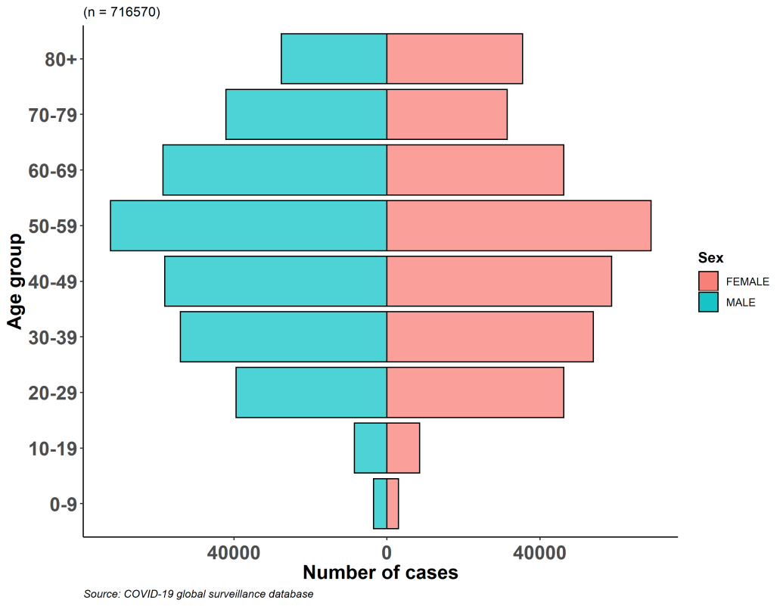
Distribution by age of confirmed COVID-19 cases reported to the WHO case-based surveillance system over time, from 24 February through 13 April, 2020

The age distribution has varied with the progression of the epidemic from 24 February (the week in which sufficient CRFs began to be reported) to the present. As shown in Figure 3, the proportions of cases aged 0-19 years and 40-59 years are stable over time, whilst a steady increase is observed in the proportion of cases aged 20-39 years, concurrent with a proportional decrease in the 60-79 and 80+ years age groups.

Figure 3: Distribution by age of confirmed COVID-19 cases reported to the WHO case-based reporting system from 24 February through 13 April, 2020. (n=715 130)

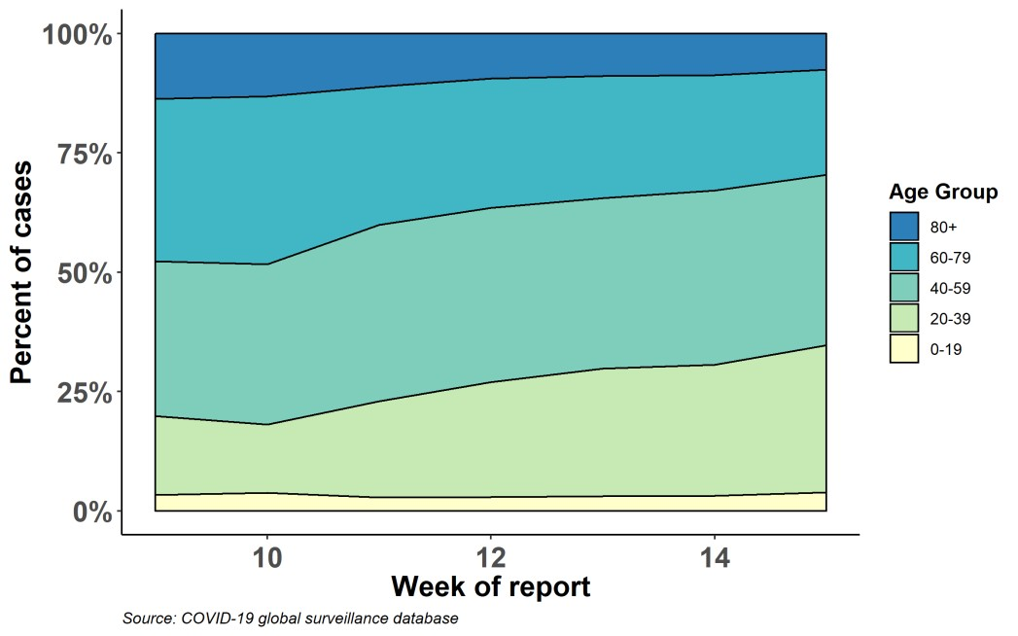
SURVEILLANCE

Table 1. Countries, territories or areas with reported laboratory-confirmed COVID-19 cases and deaths. Data as of 18 April 2020*
Reporting Country/ Territory/Area† | Total confirmed  ‡ cases |  | Total confirmed new cases | Total deaths | Total new deaths | Transmission classification§ | Days since last reported case
Western Pacific Region
China |  | 84180 | 31 | 4642 | 0 | Clusters of cases | 0
Republic of Korea |  | 10653 | 18 | 232 | 2 | Clusters of cases | 0
Japan |  | 9795 | 628 | 154 | 6 | Clusters of cases | 0
Australia |  | 6533 | 65 | 67 | 4 | Clusters of cases | 0
Philippines |  | 5878 | 218 | 387 | 25 | Clusters of cases | 0
Malaysia |  | 5251 | 69 | 86 | 2 | Clusters of cases | 0
Singapore |  | 5050 | 623 | 11 | 1 | Clusters of cases | 0
New Zealand |  | 1094 | 8 | 11 | 0 | Clusters of cases | 0
Viet Nam |  | 268 | 0 | 0 | 0 | Clusters of cases | 1
Brunei Darussalam |  | 136 | 0 | 1 | 0 | Sporadic cases | 7
Cambodia |  | 122 | 0 | 0 | 0 | Sporadic cases | 6
Mongolia |  | 31 | 0 | 0 | 0 | Sporadic cases | 1
Lao People's Democratic Republic |  | 19 | 0 | 0 | 0 | Sporadic cases | 5
Fiji |  | 17 | 0 | 0 | 0 | Sporadic cases | 1
Papua New Guinea |  | 7 | 0 | 0 | 0 | Sporadic cases | 1
Territories**
Guam |  | 135 | 0 | 5 | 0 | Clusters of cases | 3
French Polynesia |  | 55 | 0 | 0 | 0 | Sporadic cases | 4
New Caledonia |  | 18 | 0 | 0 | 0 | Sporadic cases | 15
Northern Mariana  Islands (Commonwealth of the) |  | 14 | 1 | 2 | 0 | Pending | 0
European Region
Spain |  | 188068 | 5252 | 19478 | 348 | Pending | 0
Italy |  | 172434 | 3493 | 22747 | 575 | Pending | 0
Germany |  | 137439 | 3609 | 4110 | 242 | Pending | 0
The United Kingdom |  | 108696 | 5599 | 14576 | 847 | Pending | 0
France |  | 108163 | 385 | 18659 | 760 | Pending | 0
Turkey |  | 78546 | 4353 | 1769 | 126 | Community  transmission | 0
Russian Federation |  | 36793 | 4785 | 313 | 40 | Clusters of cases | 0
Belgium |  | 36138 | 1329 | 5163 | 306 | Pending | 0
Netherlands |  | 30449 | 1235 | 3459 | 144 | Pending | 0
Switzerland |  | 26997 | 346 | 1058 | 42 | Community  transmission | 0
Portugal |  | 19022 | 181 | 657 | 28 | Pending | 0
Austria |  | 14603 | 155 | 431 | 21 | Pending | 0
Ireland |  | 13980 | 709 | 530 | 44 | Pending | 0
Sweden |  | 13216 | 676 | 1400 | 67 | Pending | 0

Israel | 12855 | 264 | 148 | 8 | Pending | 0
Poland | 8379 | 461 | 332 | 18 | Pending | 0
Romania | 8067 | 360 | 400 | 13 | Pending | 0
Denmark | 7073 | 194 | 336 | 15 | Pending | 0
Norway | 6791 | 0 | 136 | 0 | Pending | 1
Czechia | 6549 | 116 | 173 | 4 | Pending | 0
Serbia | 5690 | 372 | 110 | 7 | Pending | 0
Ukraine | 5106 | 444 | 133 | 8 | Community  transmission | 0
Belarus | 4779 | 575 | 43 | 3 | Clusters of cases | 0
Finland | 3489 | 120 | 82 | 7 | Pending | 0
Luxembourg | 3480 | 36 | 72 | 3 | Pending | 0
Republic of Moldova | 2264 | 110 | 56 | 2 | Pending | 0
Greece | 2207 | 0 | 105 | 0 | Pending | 1
Hungary | 1834 | 71 | 172 | 16 | Pending | 0
Croatia | 1814 | 23 | 36 | 1 | Pending | 0
Iceland | 1754 | 15 | 8 | 0 | Pending | 0
Kazakhstan | 1546 | 66 | 17 | 1 | Pending | 0
Estonia | 1459 | 25 | 38 | 2 | Pending | 0
Uzbekistan | 1450 | 70 | 4 | 0 | Clusters of cases | 0
Azerbaijan | 1340 | 57 | 15 | 0 | Clusters of cases | 0
Slovenia | 1304 | 36 | 66 | 5 | Pending | 0
Lithuania | 1239 | 90 | 33 | 1 | Pending | 0
Bosnia and Herzegovina | 1210 | 41 | 44 | 2 | Community transmission | 0
Armenia | 1201 | 42 | 19 | 1 | Clusters of cases | 0
North Macedonia | 1117 | 36 | 49 | 3 | Clusters of cases | 0
Slovakia | 1049 | 72 | 9 | 1 | Pending | 0
Bulgaria | 846 | 46 | 41 | 3 | Pending | 0
Cyprus | 735 | 0 | 17 | 0 | Pending | 1
Andorra | 703 | 9 | 35 | 1 | Community transmission | 0
Latvia | 682 | 7 | 5 | 0 | Pending | 0
Albania | 548 | 30 | 26 | 0 | Clusters of cases | 0
Kyrgyzstan | 506 | 17 | 5 | 0 | Pending | 0
San Marino | 426 | 0 | 38 | 0 | Community  transmission | 1
Malta | 422 | 10 | 3 | 0 | Pending | 0
Georgia | 385 | 15 | 3 | 0 | Clusters of cases | 0
Montenegro | 305 | 2 | 5 | 1 | Clusters of cases | 0
Monaco | 98 | 5 | 1 | 0 | Sporadic cases | 0
Liechtenstein | 81 | 0 | 1 | 0 | Pending | 3
Holy See | 8 | 0 | 0 | 0 | Sporadic cases | 9
Territories**
Kosovo[1] | 480 | 31 | 12 | 1 | Community  transmission | 0
Isle of Man | 289 | 31 | 4 | 0 | Pending | 0
Guernsey | 234 | 6 | 9 | 1 | Pending | 0
Jersey | 223 | 4 | 10 | 3 | Pending | 0
Faroe Islands | 184 | 0 | 0 | 0 | Pending | 10

Gibraltar | 133 | 2 | 0 | 0 | Pending | 0
Greenland | 11 | 0 | 0 | 0 | Pending | 12
South-EastAsia Region
India | 14378 | 991 | 480 | 43 | Clusters of cases | 0
Indonesia | 5923 | 407 | 520 | 24 | Community  transmission | 0
Thailand | 2733 | 33 | 47 | 0 | Pending | 0
Bangladesh | 1838 | 266 | 75 | 15 | Pending | 0
Sri Lanka | 244 | 6 | 7 | 0 | Clusters of cases | 0
Myanmar | 94 | 9 | 5 | 1 | Clusters of cases | 0
Nepal | 30 | 14 | 0 | 0 | Sporadic cases | 0
Maldives | 28 | 5 | 0 | 0 | Sporadic cases | 0
Timor-Leste | 18 | 0 | 0 | 0 | Sporadic cases | 1
Bhutan | 5 | 0 | 0 | 0 | Sporadic cases | 15
Eastern Mediterranean Region
Iran (Islamic Republic of) | 79494 | 1499 | 4958 | 89 | Community transmission | 0
Pakistan | 7481 | 456 | 143 | 8 | Clusters of cases | 0
Saudi Arabia | 7142 | 762 | 87 | 4 | Clusters of cases | 0
United Arab Emirates | 6302 | 477 | 37 | 2 | Pending | 0
Qatar | 4663 | 560 | 7 | 0 | Pending | 0
Egypt | 2844 | 171 | 205 | 9 | Clusters of cases | 0
Morocco | 2564 | 281 | 135 | 5 | Clusters of cases | 0
Bahrain | 1744 | 44 | 7 | 0 | Clusters of cases | 0
Kuwait | 1658 | 134 | 5 | 2 | Clusters of cases | 0
Iraq | 1482 | 48 | 81 | 1 | Clusters of cases | 0
Oman | 1180 | 111 | 6 | 1 | Clusters of cases | 0
Afghanistan | 908 | 63 | 30 | 0 | Clusters of cases | 0
Tunisia | 864 | 42 | 37 | 0 | Community  transmission | 0
Djibouti | 732 | 141 | 2 | 0 | Clusters of cases | 0
Lebanon | 668 | 5 | 21 | 0 | Clusters of cases | 0
Jordan | 407 | 5 | 7 | 0 | Clusters of cases | 0
Somalia | 116 | 36 | 5 | 0 | Sporadic cases | 0
Libya | 49 | 0 | 1 | 0 | Clusters of cases | 1
Syrian Arab Republic | 38 | 5 | 2 | 0 | Community  transmission | 0
Sudan | 33 | 1 | 6 | 1 | Sporadic cases | 0
Yemen | 1 | 0 | 0 | 0 | Pending | 7
Territories**
occupied Palestinian  territory | 313 | 18 | 2 | 0 | Clusters of cases | 0
Region of the Americas
United States of  America | 665330 | 32549 | 30384 | 2163 | Community  transmission | 0
Canada | 30659 | 1775 | 1250 | 202 | Community  transmission | 0
Brazil | 30425 | 2105 | 1924 | 188 | Community  transmission | 0
Peru | 13489 | 2014 | 300 | 46 | Community transmission | 0

Chile | 9252 | 445 | 116 | 11 | Community transmission | 0
Ecuador | 8450 | 225 | 421 | 18 | Community transmission | 0
Mexico | 6297 | 450 | 486 | 37 | Community  transmission | 0
Dominican Republic | 4126 | 371 | 200 | 4 | Community  transmission | 0
Panama | 4016 | 265 | 109 | 6 | Community  transmission | 0
Colombia | 3233 | 128 | 144 | 13 | Community transmission | 0
Argentina | 2694 | 96 | 122 | 7 | Community transmission | 0
Cuba | 923 | 61 | 31 | 4 | Clusters of cases | 0
Costa Rica | 642 | 16 | 4 | 0 | Clusters of cases | 0
Uruguay | 502 | 9 | 9 | 0 | Clusters of cases | 0
Bolivia (Plurinational  State of) | 465 | 24 | 31 | 2 | Clusters of cases | 0
Honduras | 442 | 16 | 41 | 6 | Clusters of cases | 0
Guatemala | 214 | 18 | 7 | 2 | Clusters of cases | 0
Venezuela (Bolivarian  Republic of) | 204 | 7 | 9 | 0 | Clusters of cases | 0
Paraguay | 199 | 25 | 8 | 0 | Community  transmission | 0
El Salvador | 177 | 13 | 7 | 1 | Clusters of cases | 0
Jamaica | 143 | 18 | 5 | 0 | Clusters of cases | 0
Trinidad and Tobago | 114 | 0 | 8 | 0 | Sporadic cases | 2
Barbados | 75 | 0 | 5 | 0 | Clusters of cases | 1
Guyana | 57 | 2 | 6 | 0 | Clusters of cases | 0
Bahamas | 54 | 1 | 9 | 1 | Clusters of cases | 0
Haiti | 43 | 2 | 3 | 0 | Clusters of cases | 0
Antigua and Barbuda | 23 | 0 | 2 | 0 | Clusters of cases | 4
Belize | 18 | 0 | 2 | 0 | Sporadic cases | 3
Dominica | 16 | 0 | 0 | 0 | Clusters of cases | 7
Saint Lucia | 15 | 0 | 0 | 0 | Sporadic cases | 6
Grenada | 14 | 0 | 0 | 0 | Clusters of cases | 6
Saint Kitts and Nevis | 14 | 0 | 0 | 0 | Sporadic cases | 2
Saint Vincent and the  Grenadines | 12 | 0 | 0 | 0 | Sporadic cases | 7
Suriname | 10 | 0 | 1 | 0 | Sporadic cases | 14
Nicaragua | 9 | 0 | 1 | 0 | Pending | 5
Territories**
Puerto Rico | 1068 | 25 | 58 | 2 | Clusters of cases | 0
Martinique | 159 | 0 | 8 | 0 | Clusters of cases | 1
Guadeloupe | 145 | 0 | 8 | 0 | Clusters of cases | 3
Aruba | 96 | 1 | 2 | 0 | Clusters of cases | 0
French Guiana | 96 | 0 | 0 | 0 | Clusters of cases | 1
Bermuda | 83 | 2 | 5 | 0 | Clusters of cases | 0
Cayman Islands | 61 | 1 | 1 | 0 | Clusters of cases | 0
Sint Maarten | 57 | 0 | 9 | 0 | Clusters of cases | 1

United States Virgin Islands | 51 | 0 | 2 | 1 | Clusters of cases | 7
Saint Martin | 35 | 0 | 2 | 0 | Sporadic cases | 3
Curaçao | 14 | 0 | 1 | 0 | Sporadic cases | 9
Falkland Islands (Malvinas) | 11 | 0 | 0 | 0 | Clusters of cases | 3
Montserrat | 11 | 0 | 0 | 0 | Sporadic cases | 4
Turks and Caicos  Islands | 11 | 0 | 1 | 0 | Sporadic cases | 1
Saint Barthélemy | 6 | 0 | 0 | 0 | Sporadic cases | 18
Bonaire, Sint Eustatius and Saba | 5 | 1 | 0 | 0 | Sporadic cases | 0
Anguilla | 3 | 0 | 0 | 0 | Sporadic cases | 14
British Virgin Islands | 3 | 0 | 0 | 0 | Sporadic cases | 17
Saint Pierre and Miquelon | 1 | 0 | 0 | 0 | Sporadic cases | 10
African Region
South Africa | 2783 | 178 | 50 | 2 | Community  transmission | 0
Algeria | 2418 | 150 | 364 | 16 | Community  transmission | 0
Cameroon | 1016 | 161 | 21 | 4 | Clusters of cases | 0
Côte d’Ivoire | 742 | 54 | 6 | 0 | Clusters of cases | 0
Ghana | 641 | 0 | 8 | 0 | Clusters of cases | 1
Niger | 627 | 18 | 18 | 3 | Clusters of cases | 0
Burkina Faso | 547 | 4 | 32 | 0 | Clusters of cases | 0
Guinea | 438 | 0 | 1 | 0 | Clusters of cases | 1
Nigeria | 373 | 0 | 11 | 0 | Clusters of cases | 2
Senegal | 342 | 7 | 3 | 1 | Clusters of cases | 0
Mauritius | 324 | 0 | 9 | 0 | Clusters of cases | 5
Democratic Republic  of the Congo | 287 | 0 | 23 | 0 | Clusters of cases | 1
Kenya | 246 | 12 | 11 | 0 | Clusters of cases | 0
Mali | 190 | 19 | 13 | 0 | Sporadic cases | 0
United Republic of  Tanzania | 148 | 54 | 5 | 1 | Sporadic cases | 0
Congo | 143 | 26 | 6 | 1 | Clusters of cases | 0
Rwanda | 138 | 0 | 0 | 0 | Sporadic cases | 1
Madagascar | 117 | 0 | 0 | 0 | Clusters of cases | 1
Ethiopia | 96 | 4 | 3 | 0 | Sporadic cases | 0
Gabon | 95 | 0 | 1 | 0 | Sporadic cases | 1
Togo | 83 | 2 | 5 | 0 | Sporadic cases | 0
Liberia | 76 | 3 | 7 | 1 | Sporadic cases | 0
Cabo Verde | 55 | 0 | 1 | 0 | Sporadic cases | 1
Uganda | 55 | 0 | 0 | 0 | Sporadic cases | 2
Zambia | 52 | 4 | 2 | 0 | Sporadic cases | 0
Equatorial Guinea | 51 | 0 | 0 | 0 | Sporadic cases | 2
Guinea-Bissau | 50 | 4 | 0 | 0 | Sporadic cases | 0
Benin | 37 | 0 | 1 | 0 | Sporadic cases | 1
Eritrea | 35 | 0 | 0 | 0 | Sporadic cases | 2
Chad | 33 | 6 | 0 | 0 | Sporadic cases | 0

Mozambique | 31 | 2 | 0 | 0 | Sporadic cases | 0
Sierra Leone | 26 | 11 | 0 | 0 | Sporadic cases | 0
Zimbabwe | 24 | 1 | 3 | 0 | Sporadic cases | 0
Angola | 19 | 0 | 2 | 0 | Sporadic cases | 9
Eswatini | 19 | 3 | 1 | 0 | Sporadic cases | 0
Malawi | 17 | 1 | 2 | 0 | Sporadic cases | 0
Namibia | 16 | 0 | 0 | 0 | Sporadic cases | 12
Botswana | 15 | 0 | 1 | 0 | Sporadic cases | 1
Central African Republic | 12 | 0 | 0 | 0 | Sporadic cases | 1
Seychelles | 11 | 0 | 0 | 0 | Sporadic cases | 11
Gambia | 9 | 0 | 1 | 0 | Sporadic cases | 6
Mauritania | 7 | 0 | 1 | 0 | Sporadic cases | 7
Burundi | 5 | 0 | 0 | 0 | Sporadic cases | 5
São Tomé and  Príncipe | 4 | 0 | 0 | 0 | Pending | 11
South Sudan | 4 | 0 | 0 | 0 | Pending | 6
Territories**
Réunion | 402 | 8 | 0 | 0 | Clusters of cases | 0
Mayotte | 245 | 12 | 4 | 1 | Clusters of cases | 0
Subtotal for all  Regions | 2 159495 | 85678 | 146075 | 6710
International  conveyance (Diamond Princess) | 712 | 0 | 13 | 0 | Not Applicable†† | 33
Grand total | 2 160207 | 85678 | 146088 | 6710
*Numbers include both domestic and repatriated cases
†The designations employed and the presentation of the material in this publication do not imply the expression of any opinion whatsoever on the part of WHO concerning the legal status of any country, territory, city or area or of its authorities, or concerning the delimitation of its frontiers or boundaries. Dotted and dashed lines on maps represent approximate border lines for which there may not yet be full agreement.
‡Case classifications are based on WHO ca s e de finitions for COVID-19.
§Transmission classification is based on a process of country/territory/area self-reporting. Classifications are reviewed on a weekly basis and may
be upgraded or downgraded as new information becomes available. Not all locations within a given country/territory/area are e qually affected; countries/territories/areas experiencing multiple types of transmission are classified in the highest category reported. Within a given transmission category, different countries/territories/areas may have differing degrees of transmission as indicated by the d iffering numbersof cases, recency of cases, and other factors.
Terms:
- No cases: Countries/territories/areas with no confirmed cases (not shown in table)
- Sporadic cases: Countries/territories/areas with one or more cases, imported or locally detected
- Clusters of cases: Countries/territories/a reas experiencing cases, clustered in time, geographic location and/or by common exposures
- Community transmission: Countries/area/territories experiencing larger outbreaks of local transmission defined through an assessmentof factors including, but not limited to:
  - Large numbers of cases not linkable to transmission chains
  - Large numbers of cases from sentinel lab surveillance
  - Multiple unrelated clusters in several areas of the country/territory/area

** “Territories” include territories, areas, overseas dependencies and other jurisdictions of similar status
[1] All references to Kosovo should be understood to be in the context of the United Nations Security Council resolution 1244 (19 99).
†† As the international conveyance (Diamond Princess) is no longer occupied, transmission classification cannot be applied.

Due to differences in reporting methods, retrospective data consolidation, and reporting delays, the number of new cases may not always reflect the exact difference between yesterday’s and today’s totals. WHO COVID-19 Situation Reports present official counts of confirmed COVID-19 cases, thus differences between WHO reports and other sources of COVID -19 data using different inclusion criteria and different data cutoff times are to be expected.
Figure 4. Epidemic curve of confirmed COVID-19, by date of report and WHO region through 18 April 2020

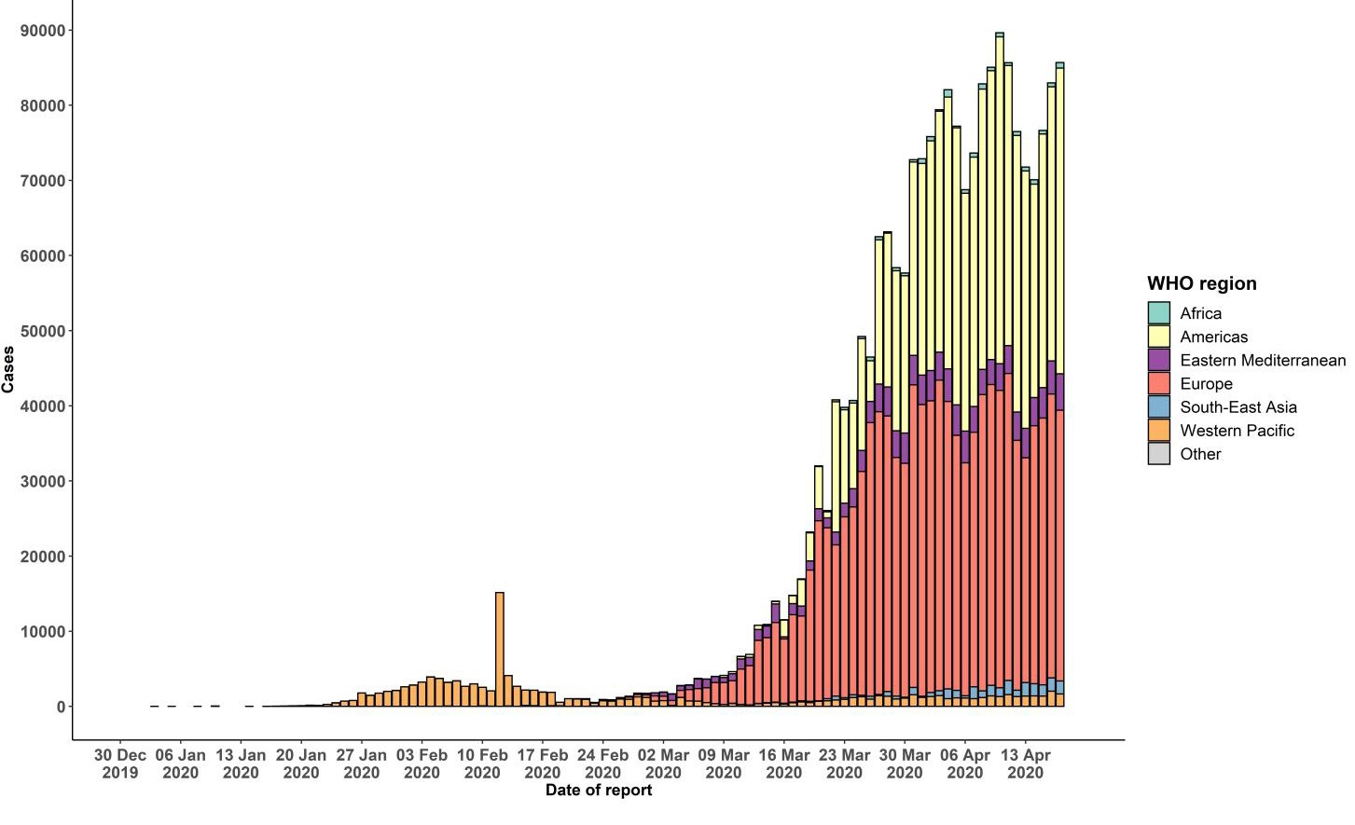

STRATEGIC OBJECTIVES

WHO’s strategic objectives for this response are to:

- Interrupt human-to-human transmission including reducing secondary infections among close contacts and health care workers, preventing transmission amplification events, and preventing further international spread*;
- Identify, isolate and care for patients early, including providing optimized care for infected patients;
- Identify and reduce transmission from the animal source;
- Address crucial unknowns regarding clinical severity, extent of transmission and infection, treatment options, and accelerate the development of diagnostics, therapeutics and vaccines;
- Communicate critical risk and event information to all communities and counter misinformation;
- Minimize social and economic impact through multisectoral partnerships.

*This can be achieved through a combination of public health measures, such as rapid identification, diagnosis and management of the cases, identification and follow up of the contacts, infection prevention and control in health care settings, implementation of health measures for travelers, awareness-raising in the population and risk communication.
PREPAREDNESS AND RESPONSE
- To view all technical guidance documents regarding COVID-19, please go to this webpage.
- WHO has developed interim guidance for laboratory diagnosis, advice on the use of masks during home care and in health care settings in the context of COVID-19 outbreak, clinical management, infection prevention and control in health care settings, home care for patients with suspected novel coronavirus, risk communication and community engagement and Global Surveillance for human infection with COVID-19.
- WHO is working closely with International Air Transport Association (IATA) and have jointly developed a guidance document to provide advice to cabin crew and airport workers, based on country queries. The guidance can be found on the IATA webpage.
- WHO has been in regular and direct contact with Member States where cases have been reported. WHO is also informing other countries about the situation and providing support as requested.
- WHO is working with its networks of researchers and other experts to coordinate global work on surveillance, epidemiology, mathematical modelling, diagnostics and virology, clinical care and treatment, infection prevention and control, and risk communication. WHO has issued interim guidance for countries, which are updated regularly.
- WHO has prepared a disease commodity package that includes an essential list of biomedical equipment, medicines and supplies necessary to care for patients with COVID-19.
- WHO has provided recommendations to reduce risk of transmission from animals to humans.
- WHO has published an updated recommendations for international traffic in relation to COVID -19 outbreak .
- WHO has activated the R&D blueprint to accelerate diagnostics, vaccines, and therapeutics.
- OpenWHO is an interactive, web-based, knowledge-transfer platform offering online courses to improve the response to health emergencies. COVID-19 courses can be found here and courses in additional national languages here. Specifically, WHO has developed online courses on the following topics:
  - Introduction to Go.Data – Field data collection, chains of transmission and contact follow-up. The Go.Data tool is available globally to WHO staff, member states and partners to support outbreak investigation, focusing on field data collection, contact tracing and visualisation of chains of transmission.
  - A general introduction to emerging respiratory viruses, including novel coronaviruses (available in Arabic, Chinese, English, French, Russian, Spanish, Hindi, Indian Sign Language, Persian, Portuguese, Serbian and Turkish);
  - Clinical care for Severe Acute Respiratory Infections (available in English, French, Russian, Indonesian and Vietnamese);
  - Health and safety briefing for respiratory diseases - ePROTECT (available in Chinese, English, French, Russian, Spanish, Indonesian and Portuguese);
  - Infection Prevention and Control for Novel Coronavirus (COVID-19) (available in Chinese, English, French,
Russian, Spanish, Indonesian, Italian, Japanese, Portuguese and Serbian); and
  - COVID-19 Operational Planning Guidelines and COVID-19 Partners Platform to support country preparedness and response (available in English and coming soon in additional languages).
- WHO is providing guidance on early investigations, which are critical in an outbreak of a new virus. The data collected from the protocols can be used to refine recommendations for surveillance and case definitions, to characterize the key epidemiological transmission features of COVID-19, help understand spread, severity, spectrum of disease, impact on the community and to inform operational models for implementation of countermeasures such as case isolation, contact tracing and isolation. Several protocols are available here. One such protocol is for the investigation of early COVID-19 cases and contacts (the “First Few X (FFX) Cases and contact investigation protocol for 2019-novel coronavirus (2019-nCoV) infection”). The protocol is designed to gain an early understanding of the key clinical, epidemiological and virological characteristics of the first cases of COVID-19 infection detected in any individual country, to inform the development and updating of public health guidance to manage cases and reduce the potential spread and impact of infection.
RECOMMENDATIONS AND ADVICE FOR THE PUBLIC

If you are not in an area where COVID-19 is spreading or have not travelled from an area where COVID-19 is spreading or have not been in contact with an infected patient, your risk of infection is low. It is understandable that you may feel anxious about the outbreak. Get the facts from reliable sources to help you accurately determine your risks so that you can take reasonable precautions (see Frequently Asked Questions). Seek guidance from WHO, your healthcare provider, your national public health authority or your employer for accurate information on COVID -19 and whether COVID-19 is circulating where you live. It is important to be informed of the situation and take appropriate measures to protect yourself and your family (see Protection measures for everyone).

If you are in an area where there are cases of COVID-19 you need to take the risk of infection seriously. Follow the advice of WHO and guidance issued by national and local health authorities. For most people, COVID-19 infection will cause mild illness however, it can make some people very ill and, in some people, it can be fatal. Older people, and those with pre-existing medical conditions (such as cardiovascular disease, chronic respiratory disease or diabetes) are at risk for severe disease (See Protection measures for persons who are in or have recently visited (past 14 days) areas where COVID -19 is spreading).

CASE DEFINITIONS

WHO periodically updates the Global Surveillance for human infection with coronavirus disease (COVID -19) document which includes case definitions.

For easy reference, case definitions are included below.

Suspect case
- A patient with acute respiratory illness (fever and at least one sign/symptom of respiratory disease, e.g., cough, shortness of breath), AND a history of travel to or residence in a location reporting community transmission of COVID-19 disease during the 14 days prior to symptom onset.
OR
- A patient with any acute respiratory illness AND having been in contact with a confirmed or probable COVID -19 case (see definition of contact) in the last 14 days prior to symptom onset;
OR
- A patient with severe acute respiratory illness (fever and at least one sign/symptom of respiratory disease, e.g., cough, shortness of breath; AND requiring hospitalization) AND in the absence of an alternative diagnosis that fully explains the clinical presentation.

Probable case
- A suspect case for whom testing for the COVID-19 virus is inconclusive.
  - Inconclusive being the result of the test reported by the laboratory.
OR
- A suspect case for whom testing could not be performed for any reason.

Confirmed case
A person with laboratory confirmation of COVID-19 infection, irrespective of clinical signs and symptoms.
- Technical guidance for laboratory testing can be found here.
Definition of contact
A contact is a person who experienced any one of the following exposures during the 2 days before and the 14 days after the onset of symptoms of a probable or confirmed case:
- Face-to-face contact with a probable or confirmed case within 1 meter and for more than 15 minutes;
- Direct physical contact with a probable or confirmed case;
- Direct care for a patient with probable or confirmed COVID-19 disease without using proper personal protective equipment1; OR
- Other situations as indicated by local risk assessments.

Note: for confirmed asymptomatic cases, the period of contact is measured as the 2 days before through the 14 days
after the date on which the sample was taken which led to confirmation.

1 World Health Organization. Infection prevention and control duringhealth care when COVID-19 is suspected
https ://www.who.int/publications-deta il/infection-prevention-and-control-during-health-care-when-novel-coronavirus-(ncov)- i nfecti on-is-suspected-20200125

